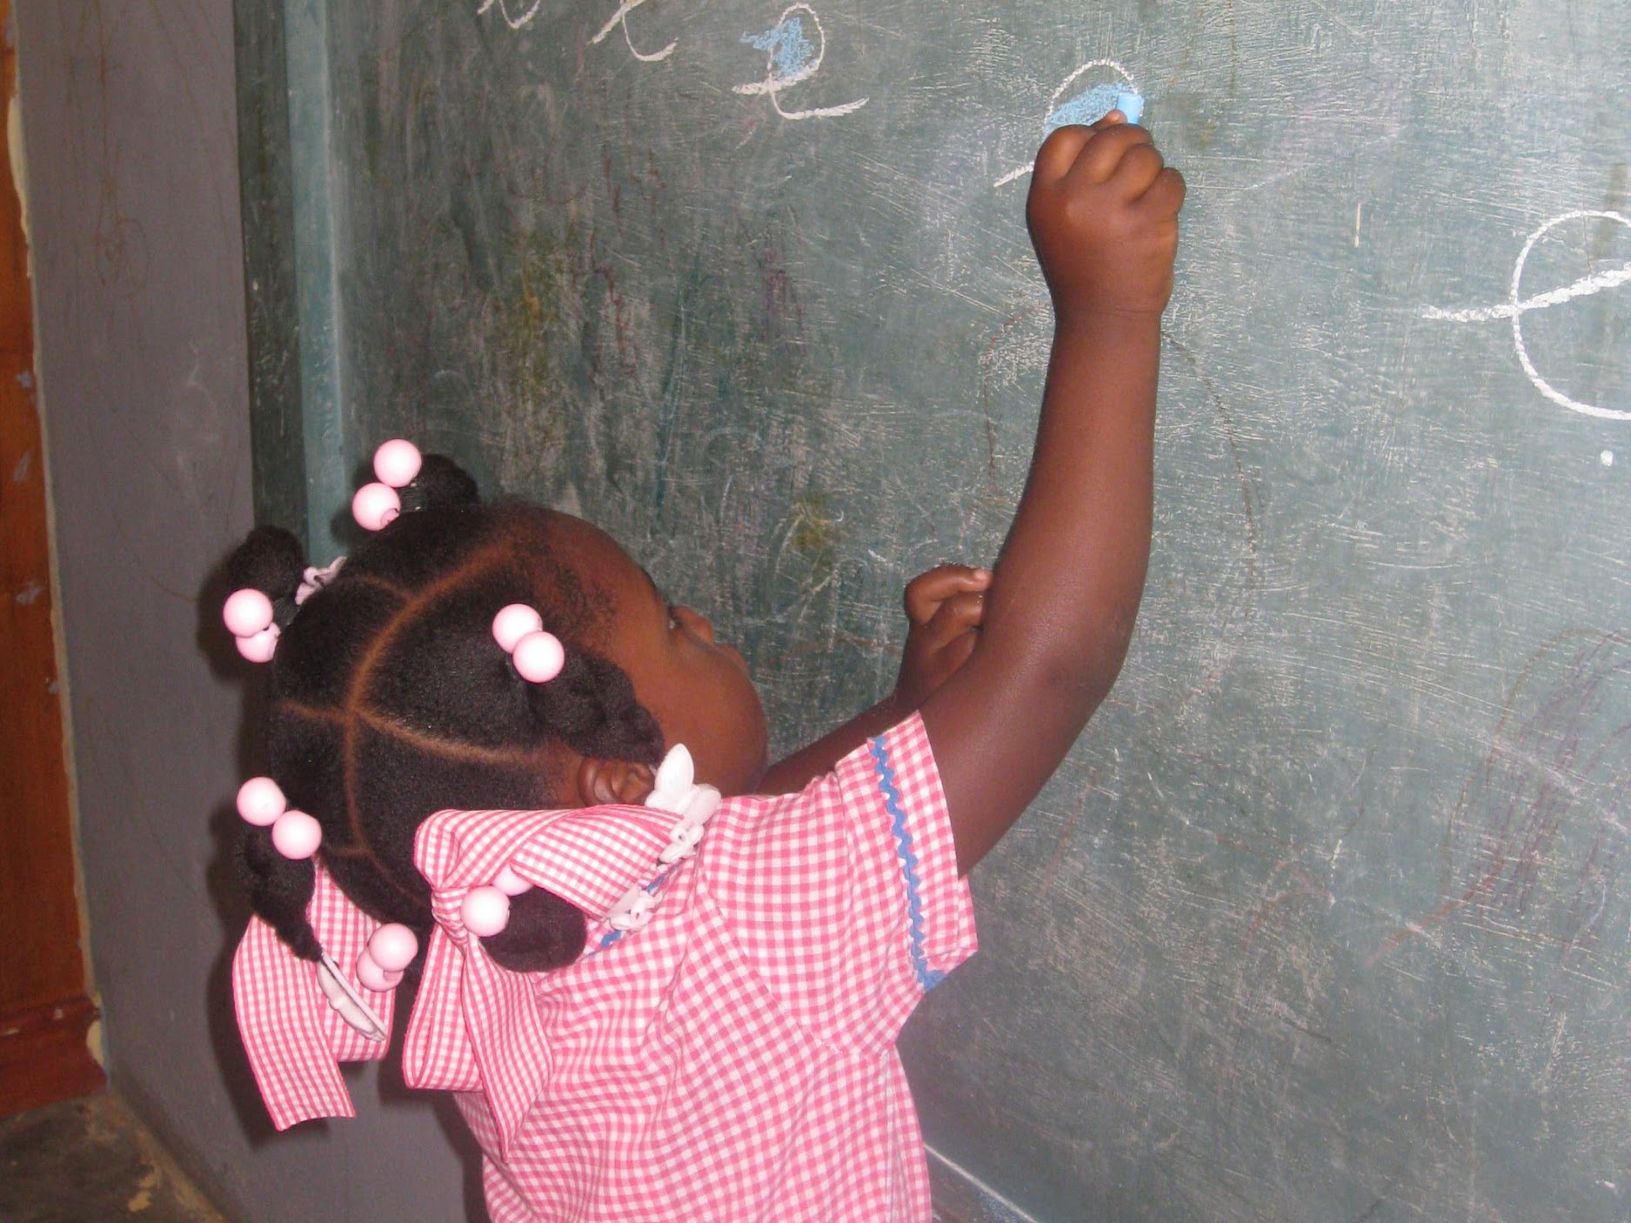

Office Use Only:

Date: ________________________

Check #: ____________________

Amount: ____________________

DB Date: ____________________

St. Charles Catholic Church

Haiti School Program

2022-2023 School Year

Thank you for supporting the six parish elementary schools operated by our two sister parishes, Our Lady of Perpetual Help and St. Joseph, which are located in Cavaillon, in southwestern Haiti. In order to best assist all the children attending these schools, we pool the donations that we receive and distribute the funds among the schools. Please see www.stcharleschurch.org/haiti for further information about this Haiti Ministry.

You may contribute online through Faith Direct by clicking on the left tab at the bottom of the Haiti webpage at www.stcharleschurch.org/haiti or by sending a check to, or dropping off a cash donation at, the St. Charles parish office.. Make the check payable to “St. Charles Church – Haiti Ministry” or write “Haiti Ministry” on the note line. In either case, we would appreciate your completion and return of this form, which you can either mail or drop off at the St. Charles parish office, or email to: haiticommittee@stcharleschurch.org.

Donation Information

Name: _________________________________________________________________________________________________________________

Address: ______________________________________________________________________________________________________________

Email: _________________________________________________________________________________________________________________

Donation Amount (Donations of any amount are appreciated): ________________________________________________

As a point of reference, $100 assists with tuition for an elementary student for one year, $50 helps provide a student a nutritious school lunch, $50 could purchase a goat for a family; $25 could buy a chicken. Your money goes farther in Haiti.

Or, online: visit http://www.stcharleschurch.org/give/and click on the first of the two “Faith Direct” icons. Then scroll down where you will see the Haiti Ministry donation selection.

If you have any questions, please contact the Haiti Committee at: haiticommittee@stcharleschurch.org.

THANK YOU FOR YOUR SUPPORT!

St. Charles Catholic Church, 3304 Washington Blvd., Arlington, VA 22201

